Building a Map Using LiDAR with ROS Melodic on Jetson Nano

## **About the project**

This tutorial will cover how to install ROS Melodic on the Jetson Nano and build a map of our environment using LiDAR and Hector SLAM.

## **Story**

Robot Operating System(ROS) is one of the popular open-source based robotics projects. The latest and current ROS1 distribution is ROS Noetic with Ubuntu 20.04 LTS Focal Fossa support. As you maybe know, ROS Noetic does not support JetPack 4.4 which comes with Ubuntu 18.04 Bionic. So, **sudo apt-get install ros-noetic**command will not be executed here. You can install and build ROS Noetic from source for Ubuntu 18.04 if you want, however it can be a frustrating and time-consuming process.

So, **ROS Melodic Morenia**, is primarily targeted to Ubuntu 18.04, which is why we have this installation tutorial on 18.04. In this tutorial, I show you how to build a map using Hector SLAM, ROS Melodic Morenia Middleware and RPLidar A1M8 on the NVIDIA Jetson Nano.

Hardware required

Before you get started with this tutorial, you will need the following:

* [NVIDIA Jetson Nano Developer Kit](https://developer.nvidia.com/buy-jetson?product=jetson_nano&location=US)
* RPLidar A1M8 with connector. The connector is being used for charging, data transfer and controlling the device.
* 5V 4A Barrel Jack Power Supply
* SD Card (64GB or 128GB)
* USB to Micro-USB cable
* To use a 5V 4A supply you will need a 2-pin jumper. I would strongly recommend to buy a 5V 4A power supply for your Jetson Nano in order to have better performance and run a high-load ROS applications.
* A computer with an internet connection and the ability to flash your microSD card. Here we’ll be using laptop.
* The Jetson Nano Developer Kit doesn’t include a WiFi module, so you have two options. You can either connect your Jetson Nano directly to your laptop using an ethernet cable and then set up a static IP and share your network, or you can add a USB WiFi adapter and connect the Nano to the same WiFi network that your laptop is using. Here we’ll be using a USB WiFi adapter.

Additional requirements

* Some experience with ROS build system is helpful but not required.
* Familiar with the Linux command line, a shell like bash, and an editor like nano.
* ROS applications use a lot of compute resources and the heat sink may not be enough for the heat generated. Consider adding a cooling fan. I recommend you use the ICE Tower CPU Cooling Fan for Nvidia Jetson Nano.

RPLidar A1M8 - 360 degree Laser Scanner

LiDAR is an optical device for detecting the presence of objects, specifying their position and gauging distance.

[RPLIDAR](http://www.slamtec.com/en/lidar/a1)is a low-cost LIDAR sensor suitable for indoor robotic SLAM(Simultaneous localization and mapping) application. It can be used in the other applications such as:

* General robot navigation and localization
* Obstacle avoidance
* Environment scanning and 3D modeling

[](https://www.electromaker.io/uploads/images/projects/1498/story/medium/Jack_Shepard_story_image_1604753782567318.gif)

RPLIDAR A1 Development Kit contains:

* RPLIDAR A1
* USB Adapter with communication cable
* Documentation

**The Micro-USB cable does not included.** So, let's get started.

Step 1 - Flash the image to the SD card and boot it up

JetPack 4.4 is the NVIDIA stack containing Linux, board drivers and SDKs for GPU, AI and ML processing. NVIDIA calls it's Linux, L4T (Linux for Tegra) and it's currently at version 32.4.2 that comes default with Ubuntu 18.04.

* Download the latest Jetpack image from the [official download](https://www.raspberrypi.org/downloads/raspbian/)page.
* Download the **etcher** tool from the [official website.](https://www.balena.io/etcher/)
* Flash the image to SD card
* Insert the microSD card into the Jetson Nano.
* Set the jumper on **J48.** J48 slot is located between the Barrel Jack connector and the Camera connector.
* Plug one end of the 5V 4A power supply into the barrel jack on the Jetson Nano.

Step 2 - Jetson Nano – Headless Setup via Serial USB port

* **Oem-config-firstboot**can configure the system through the default debugging port. On the Jetson Nano, we access this through the micro-USB connector on the board.
* Plug the USB Cable from your computer into the Jetson Nano

On your standalone computer or laptop, the serial port device name must be determined so that the client software can be used on the correct port. On Windows clients, Open **Device Manager** in Windows and expand **Ports (COM & LPT)** to find the port assignment. On Mac OS X and Linux use below command

ls -ls /dev/cu.*

A serial client program must be used on your computer to connect via Serial USB connection. The most popular client for Windows is PuTTY, which is free and works well. On Linux and OS X operating systems, the **screen** program is easily installed and it can also be used to connect to serial ports from a terminal program or system console.

You can install screen on Ubuntu:

sudo apt-get install screen

In a Terminal window run the following command:

screen /dev/cu.usbserial* 115200 -L

You should now see a screen like this:

[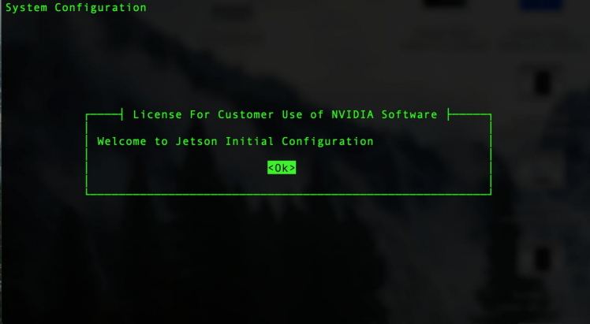](https://www.electromaker.io/uploads/images/projects/1498/story/medium/Jack_Shepard_story_image_1604753783026130.png)

* The Jetson Nano will then walk you through the install process, including setting your language, username/password, timezone, keyboard layout, wifi setup etc.
* When trying to setup networking, it can ran into a failure. You can use **nmtui** command utility to configure your WiFi network.
* After configuration, the system will restart itself.

Step 3 - How to connect to WiFi network from the command line?

**Network Manager** should be installed by default on Ubuntu Desktop installs, as well as most flavours of Ubuntu. **mtui** is a basic text-based user interface for managing Network Manager. Additionally, you can use **nmcli** as well. It is a command-line tool for controlling Network Manager and reporting network status.

Run the following command launch the **nmtui** interface. Select **Active a connection** and hit **OK**.

sudo nmtui

Example output:

[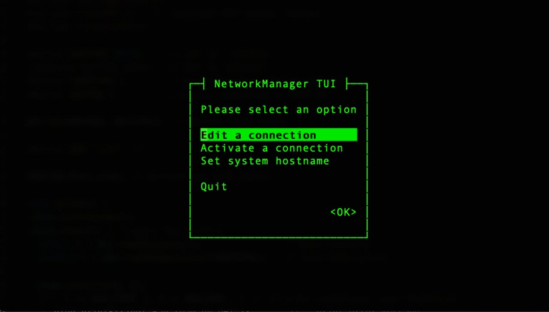](https://www.electromaker.io/uploads/images/projects/1498/story/medium/Jack_Shepard_story_image_1604753784045339.png)

Select the interface which you want to bring online then hit **Activiate** button.

A ping test may be done in order to determine the status of your Internet connection.

ping google.com

If it is successful, to connect to your Jetson Nano via your local area network, you will need to know the IP address or the hostname of your device.

You can find out it by running the following command:

Hostname -I

Then connect to your Jetson Nano via ssh using the PuTTY terminal window on Windows. Linux, the macOS comes with a command-line SSH client already installed.

Step 4 - Upgrade all installed packages on your Jetson

At this point it’s a good idea to run some updates. You can do that by entering the commands below on the Nano.

sudo apt-get updatesudo apt-get upgrade

Once you are done, you can reboot the Jetson Nano with this command:

sudo reboot now

Step 5 - Turn on the fan and maximum the frequency

ROS applications use a lot of compute resources and the passive heat sink may not be enough for the heat generated. Consider adding a cooling fan.

Next, we will lock Jetson Nano at its maximum frequency and power mode by running the following commands:

sudo jetson_clocks

This will spin the fan, as well as set the CPU and GPU clocks to their maximum value in the current performance profile.

To force run the fan:

sudo /usr/bin/jetson_clocks --fan

To see the current status:

sudo /usr/bin/jetson_clocks --show

Output:

SOC family:tegra210 Machine:NVIDIA Jetson Nano Developer KitOnline CPUs: 0-3CPU Cluster Switching: Disabledcpu0: Online=1 Governor=schedutil MinFreq=1479000 MaxFreq=1479000 CurrentFreq=1479000 IdleStates: WFI=0 c7=0cpu1: Online=1 Governor=schedutil MinFreq=1479000 MaxFreq=1479000 CurrentFreq=1479000 IdleStates: WFI=0 c7=0cpu2: Online=1 Governor=schedutil MinFreq=1479000 MaxFreq=1479000 CurrentFreq=1479000 IdleStates: WFI=0 c7=0cpu3: Online=1 Governor=schedutil MinFreq=1479000 MaxFreq=1479000 CurrentFreq=1479000 IdleStates: WFI=0 c7=0GPU MinFreq=921600000 MaxFreq=921600000 CurrentFreq=921600000EMC MinFreq=204000000 MaxFreq=1600000000 CurrentFreq=1600000000 FreqOverride=1Fan: speed=255NV Power Mode: MAXN

We want to ensure that these settings will be saved at next jetson boot up. Firstly, we need to install **nano** editor.

sudo apt install nano -y

Let's create rc.local file. Run below command on terminal:

sudo nano /etc/rc.local

Add the following lines to etc/rc.local.

#!/bin/sh -e# rc.local#Maximize performancesecho 1 > /sys/devices/system/cpu/cpu0/online echo 1 > /sys/devices/system/cpu/cpu1/online echo 1 > /sys/devices/system/cpu/cpu2/online echo 1 > /sys/devices/system/cpu/cpu3/online echo performance > /sys/devices/system/cpu/cpu0/cpufreq/scaling_governor nvpmodel -m 0 ( sleep 60 && jetson_clocks && /usr/bin/jetson_clocks --fan )&exit 0

And then press CRTL + X and then Y. Now make it executable:

sudo chmod +x /etc/rc.local

When your Jetson nano has started, your jetson clocks will also start.

Step 6 - Create a swap file(optional)

As you know, Jetson Nano has only 4GB RAM, it is not enough to run a high-load ROS applications. Excessive amount of memory would be required for building those packages.

To avoid from memory crashing, we should define swap-space for Jetson Nano. Before we begin, we can check if the system already has some swap space available.

free -h

If your system does not have swap space available, run the below script to add a 4GB swap file.

sudo fallocate -l 4G /var/swapfilesudo chmod 600 /var/swapfilesudo mkswap /var/swapfilesudo swapon /var/swapfilesudo bash -c 'echo "/var/swapfile swap swap defaults 0 0" >> /etc/fstab'

And reboot your device

sudo shutdown -r now

After reboot, verify it using below command:

free -h

Let's get started with installing ROS Melodic on the Jetson Nano.

Step 7 - ROS Melodic package installation and setup

The official steps for installing ROS are at [this link,](http://wiki.ros.org/ROS/Installation)but I will walk you through the process below so that you can see what each step should look like. Installing the Robot Operating System on the Jetson Nano is the same like on the laptop or computer.

Set up the Jetson Nano to accept software from **packages.ros.org:**

sudo sh -c 'echo "deb http://packages.ros.org/ros/ubuntu $(lsb_release -sc) main" > /etc/apt/sources.list.d/ros-latest.list'

If the command succeeds, you won’t see any output message.

By running the following command, we will download the key from **Ubuntu’s keyserver** into the trusted set of keys:

sudo apt-key adv --keyserver 'hkp://keyserver.ubuntu.com:80' --recv-key C1CF6E31E6BADE8868B172B4F42ED6FBAB17C654

Output:

Executing: /tmp/apt-key-gpghome.22OkICzKyz/gpg.1.sh --keyserver hkp://keyserver.ubuntu.com:80 --recv-key C1CF6E31E6BADE8868B172B4F42ED6FBAB17C654gpg: key F42ED6FBAB17C654: public key "Open Robotics <info@osrfoundation.org>" importedgpg: Total number processed: 1gpg: imported: 1

Update the packages index:

sudo apt update

Now pick how much of ROS you would like to install. ROS has many different flavors of installations: **desktop**, **desktop-full**, **ros_core**, **robot**, etc.

* **Desktop-Full Install:** : Everything in **Desktop** plus 2D/3D simulators and 2D/3D perception packages
* **Desktop Install:**Everything in **ROS-Base** plus tools like [rqt](http://wiki.ros.org/rqt)and [rviz](http://wiki.ros.org/rviz)
* **ROS-Base: (Bare Bones)** ROS packaging, build, and communication libraries. No GUI tools.

I’ll go with installing **Desktop Install**here.

sudo apt install ros-melodic-desktop

If you plan to use ROS together with the simulator (also includes tools such as rqt, rviz and others):

sudo apt-get install ros-melodic-desktop-full

Initialize **rosdep**. Rosdep enables you to easily install system dependencies for source code you want to compile and is required to run some core components in ROS:

if you see below error message:

sudo: rosdep: command not found

Run the below command to fix it:

sudo apt install python-rosdep

Now initialize rosdep again:

sudo rosdep init rosdep update

If you are not comfortable with entering environment variables manually each time, you may configure it in a way that it add itself in your bash session on every new shell startup. So, Update your .bashrc script:

echo "source /opt/ros/melodic/setup.bash" >> ~/.bashrc source ~/.bashrc

Now the Jetson Nano is ready to execute ROS packages and become the brain of your autonomous robot.

Check which version of ROS you have installed. If you see your ROS version as the output, congratulations you have successfully installed ROS. Run the below command.

rosversion -d

If everything is correct, we will get the following screen:

melodic

Step 8 - Connection of RPLiDAR Sensor

Connect your RPLiDAR to your Jetson Nano using Micro USB Cable.

[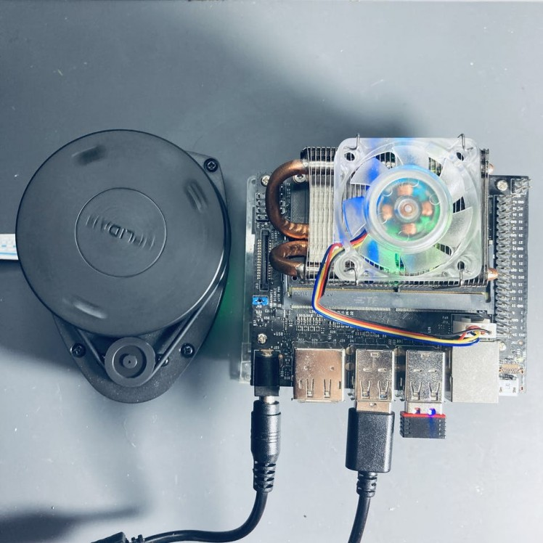](https://www.electromaker.io/uploads/images/projects/1498/story/medium/Jack_Shepard_story_image_1604753785178432.jpeg)

Connect your RPLiDAR to your Jetson Nano using Micro USB Cable. Nano is ready to communicate with LiDAR without any additional drivers. Through this connection, we are able to obtain scan data and control speed of scanning.

Once you have connected the RPLiDAR to your Raspberry Pi, type the following command line to check the permissions:

Open your terminal and run the following command.

ls -l /dev | grep ttyUSB

Output of the following command must be:

crw-rw---- 1 root dialout 188, 0 Oct 30 18:10 ttyUSB0

Run below command to change permission:

sudo chmod 666 /dev/ttyUSB0

Once the permissions are configured, you have to download and install the RPLIDAR ROS packages.

Step 9 - Configure a catkin workspace and installing ROS packages for the RPlidar

The next goal is to create a workspace - a catkin workspace - for our RPLIDAR application and its supplements. The ROS system needs a master, where all devices are registered and where they can publish their data and receive new one from other nodes. Here it will be our Jetson Nano.

Install the following dependencies:

sudo apt-get install cmake python-catkin-pkg python-empy python-nose python-setuptools libgtest-dev python-rosinstall python-rosinstall-generator python-wstool build-essential git

Create the catkin root and source folders:

mkdir -p ~/catkin_ws/srccd ~/catkin_ws/

and source it to bashrc:

echo "source $HOME/catkin_ws/devel/setup.bash" >> ~/.bashrc

Okay, we’re ready to start installing RPLIDAR ROS package. Go to the source folder of the catkin workspace that you just created:

cd src

Clone the ROS node for the Lidar in the catkin workspace.

sudo git clone https://github.com/Slamtec/rplidar_ros.git

After that build with catkin.

cd ~/catkin_ws/

Run **catkin_make** to compile your catkin workspace.

catkin_make

Then run to source the environment with your current terminal.**Don't close the terminal.**

source devel/setup.bash

and launch RPILIDAR launch file

roslaunch rplidar_ros rplidar.launch

Let us first look at how raw data from LiDAR look like when they are published on topic /scan. Just follow the steps below.

Listen to the topic /scan:

rostopic echo /scan

Now you should be able to see in the terminal the data from the LiDAR sensor.

When you try to use the **rviz** command by redirecting GUI display using X11 forwarding:

rviz

You will still see the bellow error message:

[ERROR] [1604096487.578234605]: Unable to create the rendering window after 100 tries.[ INFO] [1604096487.578328462]: Stereo is NOT SUPPORTEDterminate called after throwing an instance of 'std::logic_error' what(): basic_string::_M_construct null not validAborted (core dumped)

Rviz cannot be started remotely. If you really want to start it, it is better to connect with VNC.

Step 10 - Installing VNC Server

Considering the limited RAM (4GB) and the fact that many use cases do not require desktop environment, replacing Ubuntu Desktop with a simpler but more memory-efficient one can save you around 1GB RAM. Using lightweight desktop environment reduces the startup memory consumption.

There are a large number of windows managers available for Linux. For a light weight desktop manager for an embedded application you might want to consider [Xfce Desktop Environment](https://xfce.org/)or [Lxde Desktop Environment.](http://lxde.org/)

So type the following command:

sudo apt-get install xfce4-goodies xfce4

Install LightDM display manager:

sudo apt-get install lightdm

While installing XFCE, you’ll see a prompt to select your default display manager:

[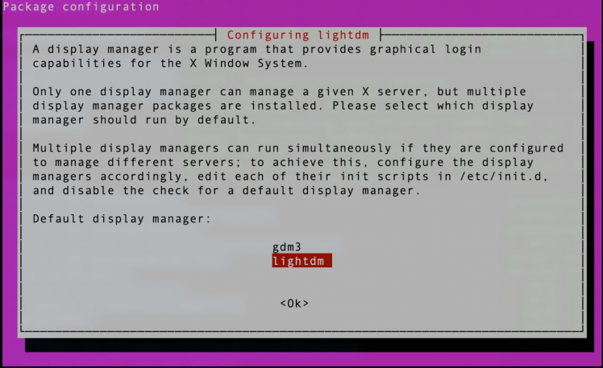](https://www.electromaker.io/uploads/images/projects/1498/story/medium/Jack_Shepard_story_image_1604753785793782.png)

Use the arrow-keys to select **lightdm** instead of **gdm3**, press Tab to move to OK, and press Enter.

Then reboot your jetson:

sudo reboot

Connect to your jetson via SSH and open a terminal and issue the following

cat /etc/X11/default-display-manager

This will return :

/usr/sbin/lightdm

To enable automatic login – open a terminal and use any text editor for configuration file –[lightdm.conf](http://lightdm.conf/)**.** If the configuration file already exists then edit it. Otherwise, create a new configuration file – **lightdm.conf**.

sudo nano /etc/lightdm/lightdm.conf

and, append the file with:

[Seat:*]autologin-user=<user_name>autologin-user-timeout=0user-session=xfce

Finally, remove ubuntu-desktop packages

sudo apt remove --purge ubuntu-desktopsudo apt autoremove

There are also several different VNC servers available in Ubuntu repositories such as [TightVNC](https://www.tightvnc.com/), [TigerVNC](http://tigervnc.org/)and [x11vnc](http://www.karlrunge.com/x11vnc/). Each VNC server has different strengths and weaknesses in terms of speed and security.

For the server, the easiest for Ubuntu would be **X11VNC**. It is very simple to install and to use. This program is not only free of charge, open source, but also supports OpenGL programs. For example, **rviz** and other programs can also open normally.

Open a terminal and run the following commands to update default repositories and install required packages.

sudo apt-get install x11vnc -y

Now create a password to connect using vnc viewer from the client system. This will not require any username to connect vnc.

x11vnc -storepasswd /etc/x11vnc.pwd

After the successful installation of the x11vnc server on your system. Let’s start it using the following command. Change the parameters as per your setup.

sudo x11vnc -forever -loop -noxdamage -repeat -rfbauth /etc/x11vnc.pwd -rfbport 5900 -shared

The VNC server will start on default port 5900. Leave command prompt running.

Step 11 - Set Up SSH Tunneling on Linux and macOS(optional)

VNC is not an encrypted protocol and can be subject to packet sniffing. The recommended approach is to create an [SSH tunnel](https://linuxize.com/post/how-to-setup-ssh-tunneling/)that will securely forward traffic from your local machine on port 5901 to the server on the same port.

If you run Windows, you can set up SSH Tunneling using the [PuTTY SSH client](https://www.putty.org/).

If you run Linux, macOS, or any other Unix-based operating system on your machine, you can easily create an SSH tunnel with the following command:

ssh -L 5901:127.0.0.1:5901 -N -f -l username@server_ip_address

You will be prompted to enter the user password.

Do not forget to replace **username** and **server_ip_address**with your username and the IP address of your Jetson Nano.

Step 12 - Connecting to VNC server using VNC client

Now that the SSH tunnel is created, it is time to open your Vncviewer and to connect to the VNC Server at **localhost:5901.**

You can use any VNC viewer such as TigerVNC, TightVNC, RealVNC, UltraVNC, Vinagre and etc.We’ll be using **RealVNC**. Open the viewer, enter localhost:5901, and click on the Connect button.

[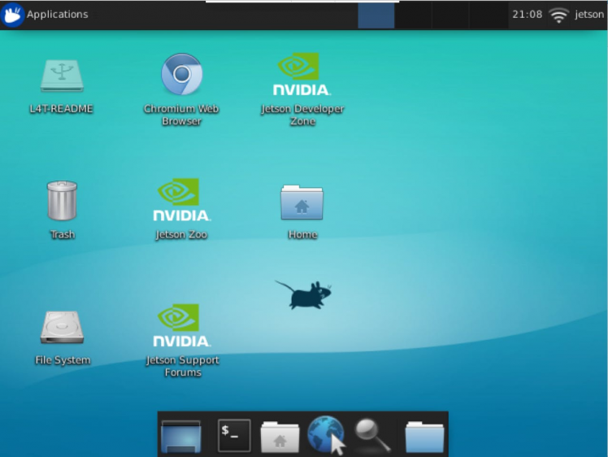](https://www.electromaker.io/uploads/images/projects/1498/story/medium/Jack_Shepard_story_image_1604753787161634.png)

Then run below command to adjust the screen resolution of a virtual desktop. Xrandr is used to set the size, orientation and/or reflection of the outputs for a screen.

xrandr --fb 1270x720

[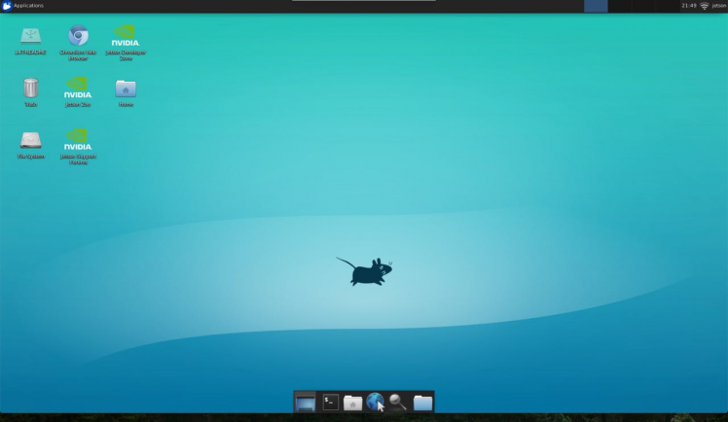](https://www.electromaker.io/uploads/images/projects/1498/story/medium/Jack_Shepard_story_image_1604753788535097.png)

Congratulations! We are done with the VNC connection.

Step 13 - Running rviz with VNC on a remote computer

Open a terminal windows and run the following command:

cd ~/catkin_ws/

Then run to source the environment with your current terminal.

source devel/setup.bash

and launch RPILIDAR launch file

roslaunch rplidar_ros rplidar.launch

Let’s check it further with Rviz. Open a new terminal window and run the following command:

rviz

You'll see the rviz window pops out.

[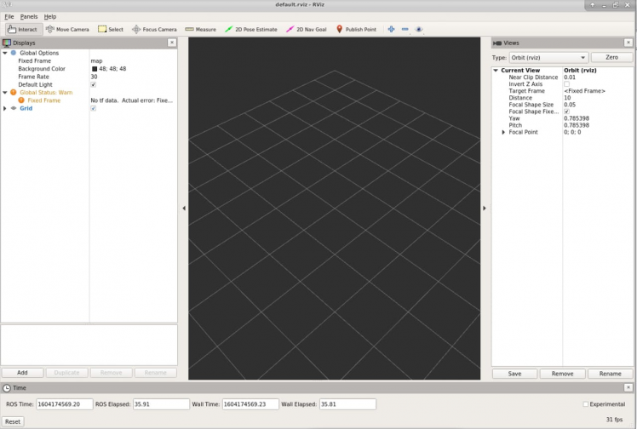](https://www.electromaker.io/uploads/images/projects/1498/story/medium/Jack_Shepard_story_image_1604753789677609.png)

The visualization is not showing due to problems with the frame name. We now need to tell **rviz** which fixed frame we want to use. Change fixed frame to **laser.**

To add objects you want to visualize, click Add button located in the left bottom corner of the RViZ GUI and then select LaserScan object, and then set the topic of LaserScan object to /scan. Increase the size to 0.03 to see the laser scan data clearly.

[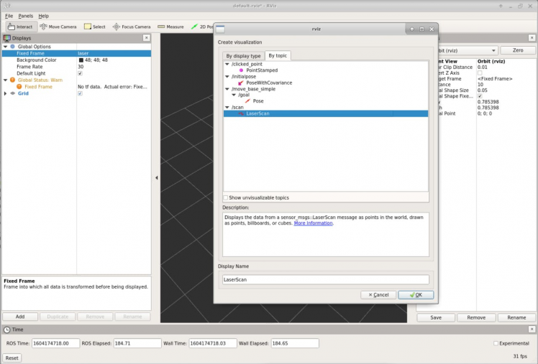](https://www.electromaker.io/uploads/images/projects/1498/story/medium/Jack_Shepard_story_image_1604753790601870.png)

Now you should see the visualization of LiDAR sensor measurements in the RViZ GUI.

[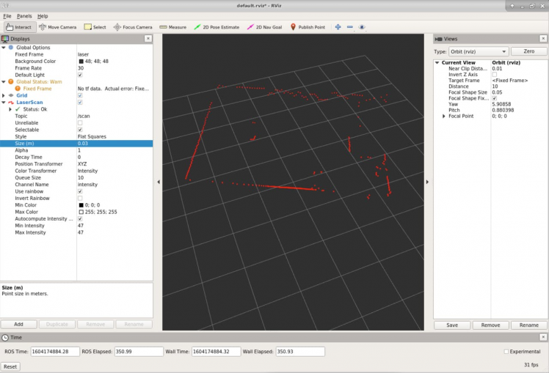](https://www.electromaker.io/uploads/images/projects/1498/story/medium/Jack_Shepard_story_image_1604753791879202.png)

**Rviz** will open with a map of the RPLIDAR’s surroundings. Alright, so we can visualize the laser scan data using rviz. So now the next step will be to create a map out of it.

Step 14 - How to build a Map Using Hector SLAM

We will now add the mapping functionality to our system. We use the**Hector-SLAM** package, since it enables us to create maps. A map is a representation of the environment where the LIDAR is operating.

**Hector SLAM** is a mapping algorithm which only uses laser scan information to extract the map of the environment. The LIDAR uses laser sensor data to create a map of its surrounding using a technique called SLAM – Simultaneous Localization and Mapping. **SLAM** is an algorithm to create map (mapping) as well as to calculate own position within the map (localization). The Hector SLAM method can be used without odometry. It only needs the data from Lidar and relies on scan matching approach to construct a complete map.

* [hector_mapping](http://library.isr.ist.utl.pt/docs/roswiki/hector_mapping.html)The SLAM node.
* [hector_geotiff](http://library.isr.ist.utl.pt/docs/roswiki/hector_geotiff.html)Saving of map and robot trajectory to geotiff images files.

The hector-mapping nodes depend on Qt4, so you need to install it first.

sudo apt-get install qt4-qmake qt4-dev-tools

The hector_slam can be installed like a ROS node of the LIDAR into the src folder of the workspace. Move into **catkin_w/src** folder:

cd ~/catkin_ws/src

Clone the Hector SLAM source files:

git clone https://github.com/tu-darmstadt-ros-pkg/hector_slam.git

Since, we do not have **base_footprint** and our **base_llink** will be our **odometry frame,** there is need to modify two files. Hector SLAM’s launch file which can be found at:

cd ~/catkin_ws/src/hector_slam/hector_mapping/launch/mapping_default.launch

Modify the below lines:

<arg name="base_frame" default="base_footprint"/><arg name="odom_frame" default="nav"/>

replace **base_footprint** and **nav** into **base_link:**

<arg name="base_frame" default="base_link"/><arg name="odom_frame" default="base_link"/>

Then, at the end of this file, find out the below line

<!--<node pkg="tf" type="static_transform_publisher" name="map_nav_broadcaster" args="0 0 0 0 0 0 map nav 100"/>-->

Modify into:

<node pkg="tf" type="static_transform_publisher" name="base_to_laser_broadcaster" args="0 0 0 0 0 0 base_link laser 100"/>

Then go to **/catkin_ws/src/hector_slam/hector_slam_launch/launch** folder and open **tutorial.launch** file:

sudo nano tutorial.launch

Change the below line:

<param name="/use_sim_time" value="true"/>

into:

<param name="/use_sim_time" value="false"/>

Open a terminal window and run the following command:

cd ~/catkin_ws/

Then run build source

catkin build

The catkin build command is part of the **catkin_tools**package. On apt-get the package is called python-catkin-tools.

source devel/setup.bash

If you see below error message

Project 'cv_bridge' specifies '/usr/include/opencv' as an include dir, which is not found.

You can resolve the errors with the following command:

cd /usr/includesudo ln -s opencv4/ opencv

And then run the following at the command line:

roslaunch rplidar_ros rplidar.launch

Leave this terminal window running.

Alright we are almost there, now the final step is to launch the above file and see the result in **rviz**. So let’s do it. Open up a second terminal and start the mapping process using below command:

roslaunch hector_slam_launch tutorial.launch

This launch file starts the **hector_mapping** node as well as the **hector_trajectory_server** and **hector_geotiff** nodes needed for generating **geotiff** maps.

Now you should be able to see the map in **rviz** like below:

Completed map of the room in RViz

[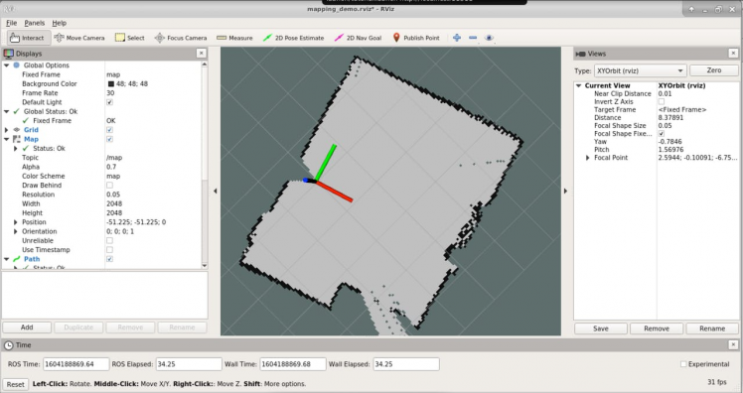](https://www.electromaker.io/uploads/images/projects/1498/story/medium/Jack_Shepard_story_image_1604753792858450.png)

Completed map of the room in RViz

**Hector_geotiff** saves the map and robot trajectory to **geotiff** image files. Run the below command on a new terminal prompt:

rostopic pub syscommand std_msgs/String "savegeotiff"

The **savegeotiff** map can be found in the **hector_geotiff/map** directory.

Completed map of the room

[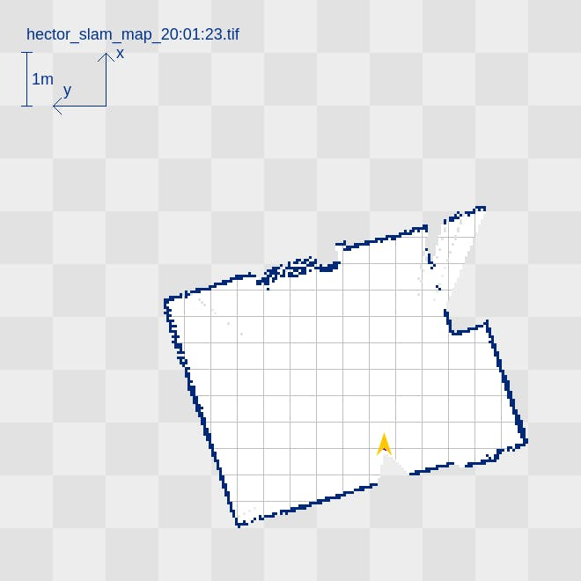](https://www.electromaker.io/uploads/images/projects/1498/story/medium/Jack_Shepard_story_image_1604753793827315.png)

Completed map of the room

The map is a 2D grid based SLAM map created by the **hector_slam**library for ROS. It is based on the LiDAR sensor data and an approximative position of the robot.